DBMS Technical Task
Dhanalakshmi K
E25AI110
BSc. Computer Science
With
Artificial Intelligence

Week 10: Advanced SQL Query System:
The e-commerce company wants to perform advanced analysis on customer purchases, product pricing, and sales performance. The management team needs complex reports to identify high-value customers, expensive products, and business trends.
Find Products Above Average Price Task:
- Find products priced above the average price.
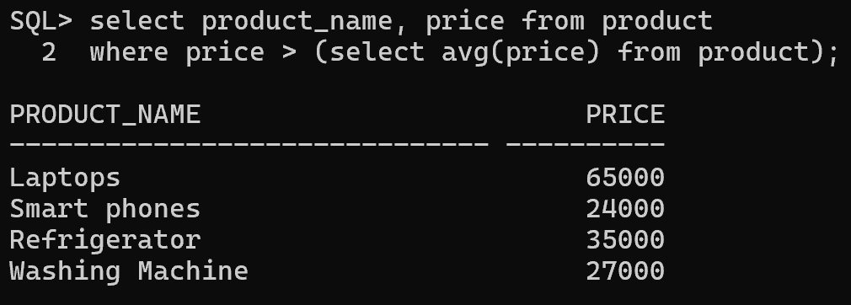
- Display product name, category, and price.
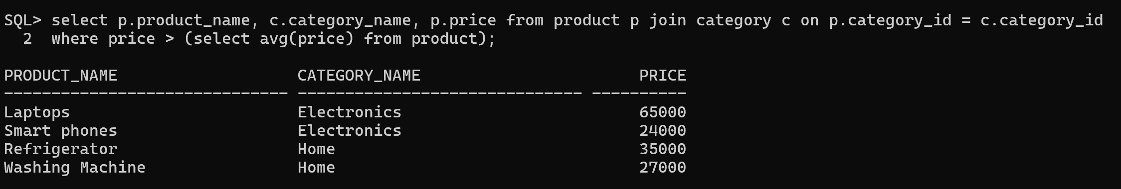
- Identify expensive products in each category
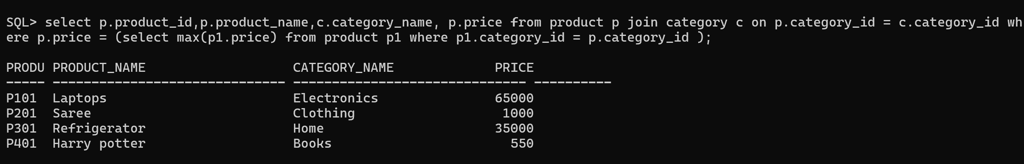
- Find products with price higher than a selected category average.
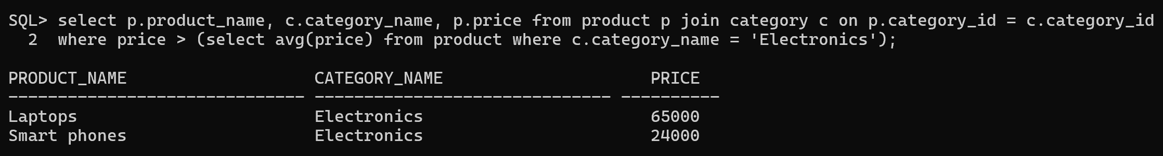

Identify Customers with Maximum Purchases Task:
- Customer who spent the highest amount.
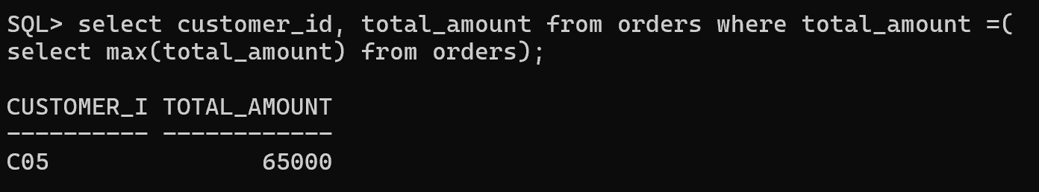
- Customers with maximum number of orders.
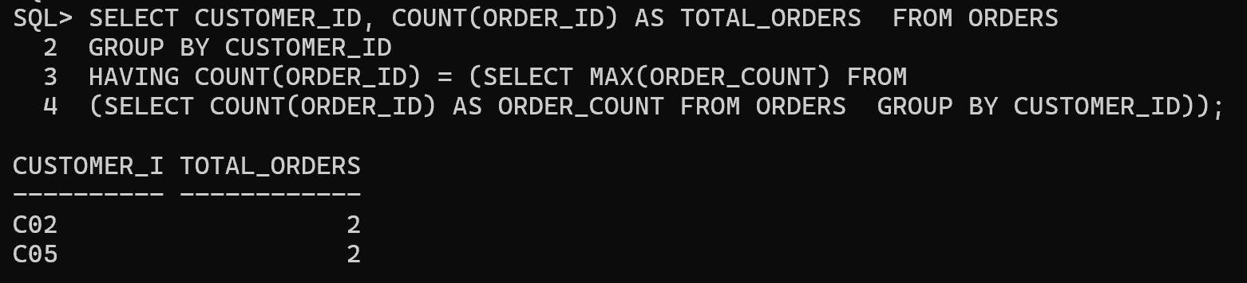
- Customers whose spending is above average.
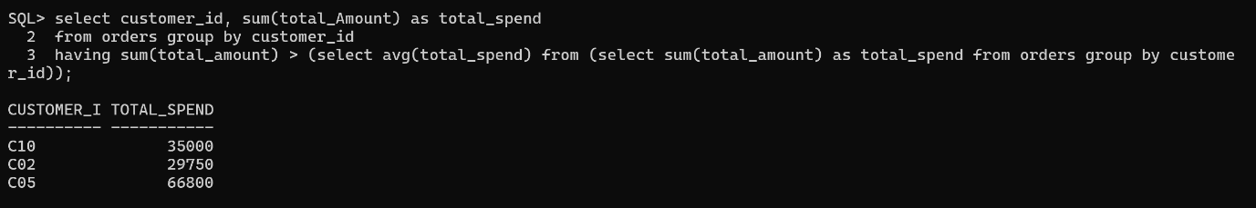
- Top 5 valuable customers.
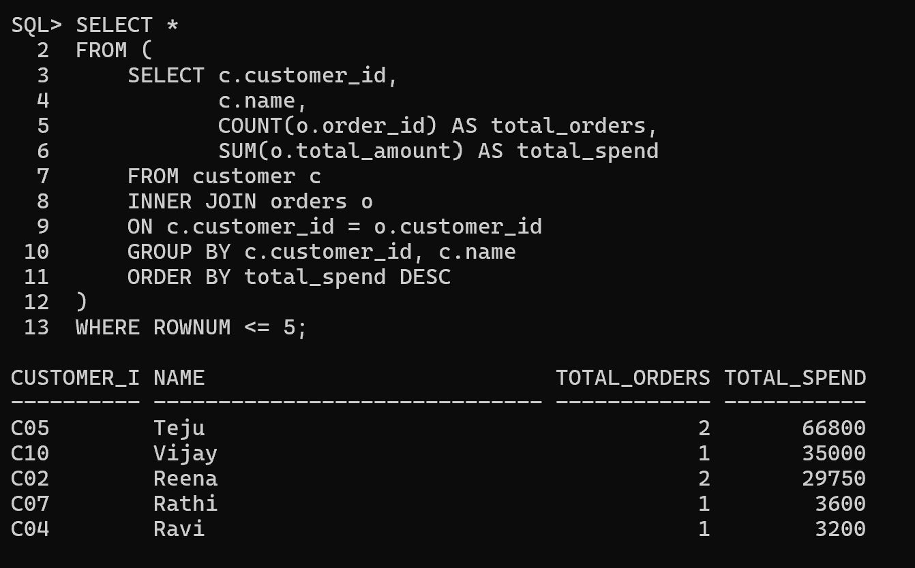

Generate Complex Business Queries
Query 1: Best-Selling Product
Find products with maximum sales quantity. Tasks:
- Display product name.
- Total quantity sold.
- Total revenue generated.
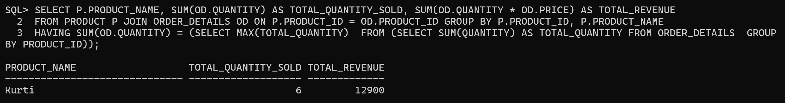

Query 2: High-Value Customers
Find customers whose total purchase amount is greater than average customer spending.
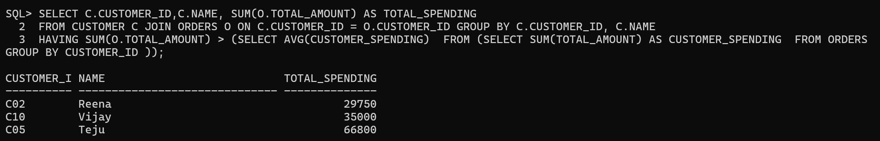
Query 3: Category Performance Analysis
Find:
- Highest revenue-generating category.
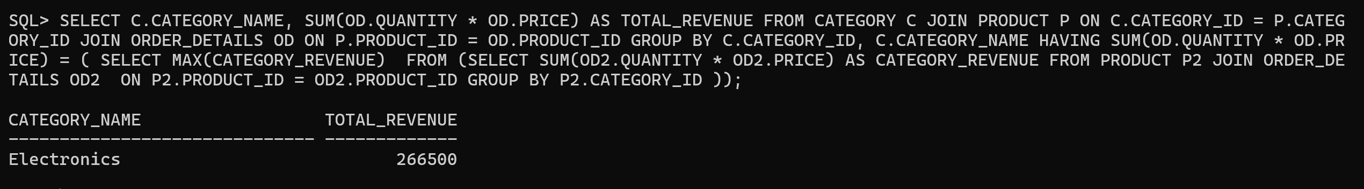
- Number of products sold in each category.
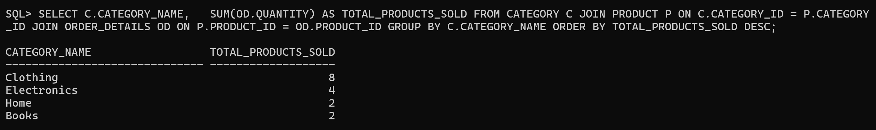
- Average product price by category.
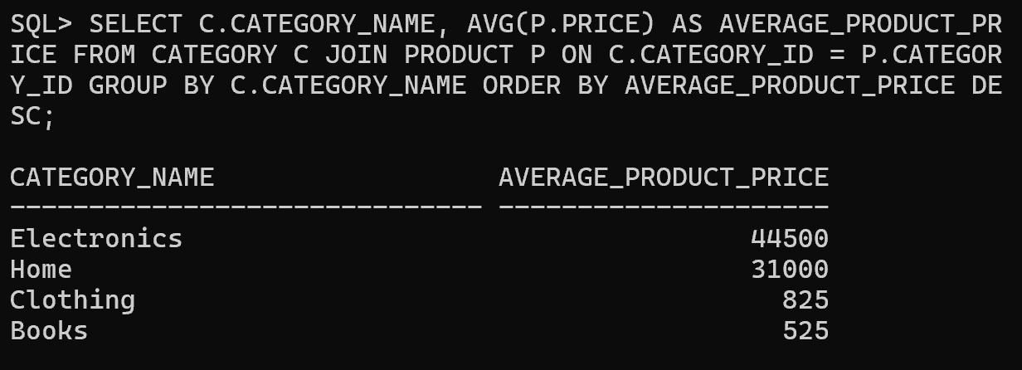
Query 4: Customer Purchase History
Display:
- Customer name
- Number of orders
- Total purchase amount
- Most purchased product
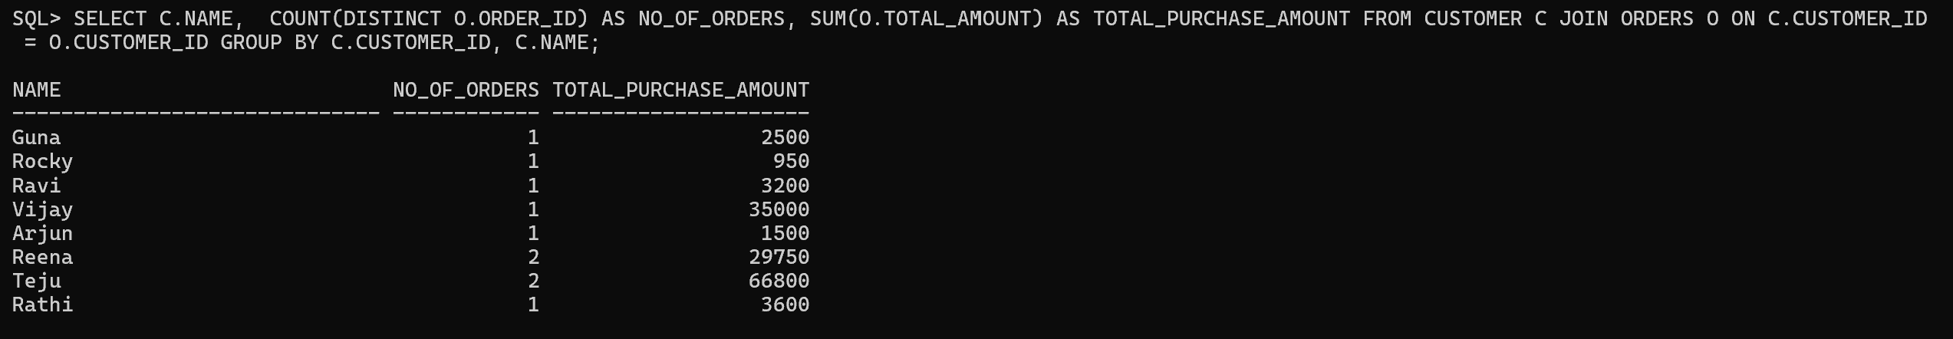

Prepare Advanced SQL Report
Report 1: Premium Product Report
Display:
- Product Name
- Category
- Price
- Stock Availability Condition: Products above average price.
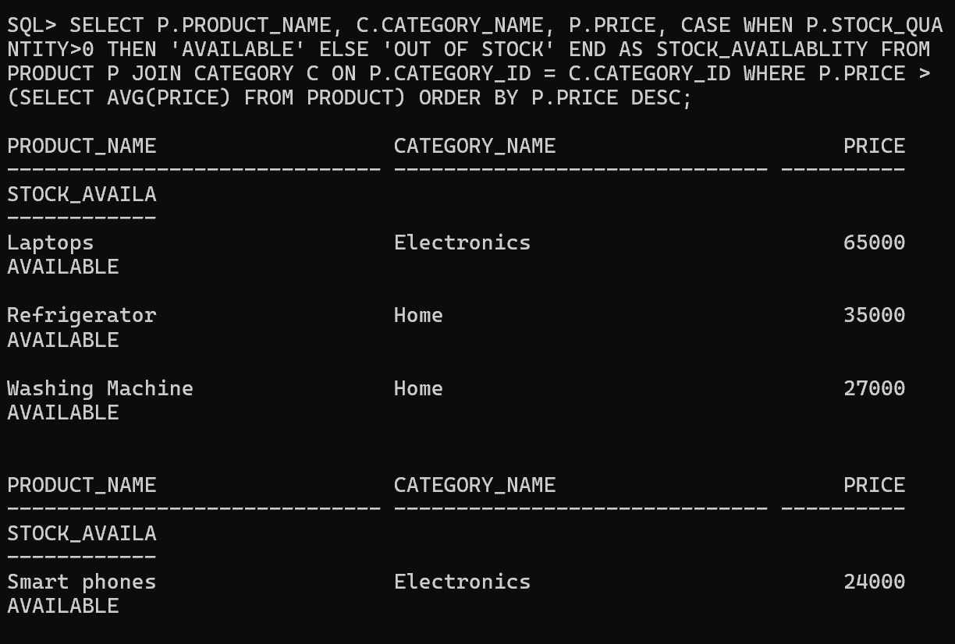
Report 2: Customer Value Report
Display:
- Customer Name
- Total Orders
- Total Spending
- Customer Category
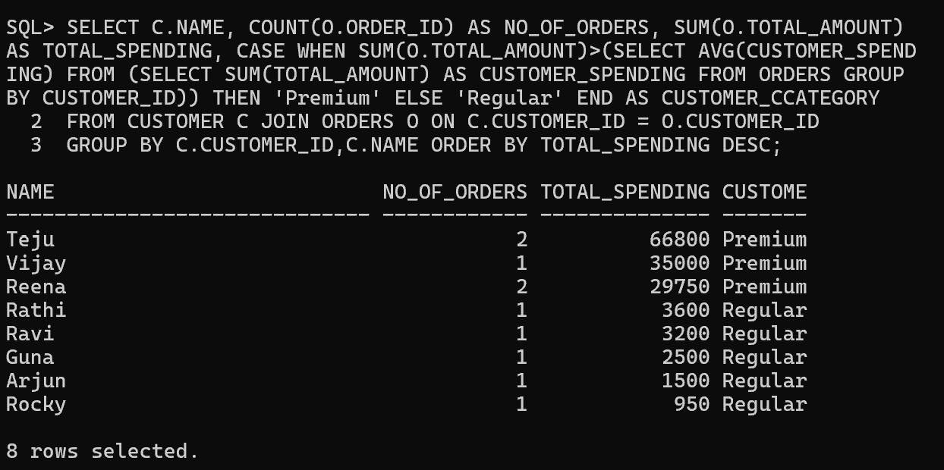

Report 3: Sales Performance Report
Display:
- Product-wise sales
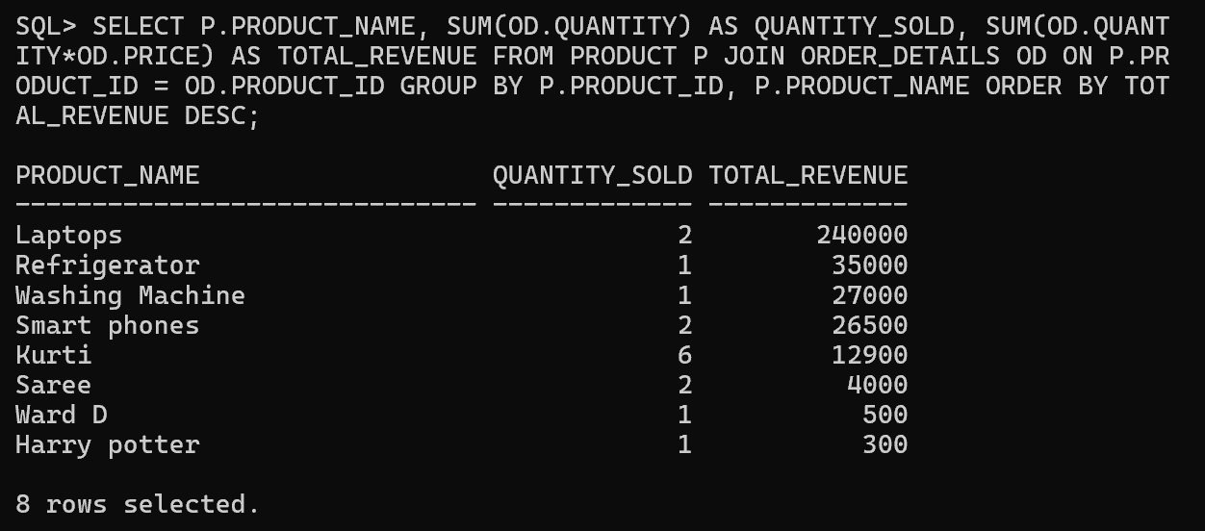
- Category-wise revenue
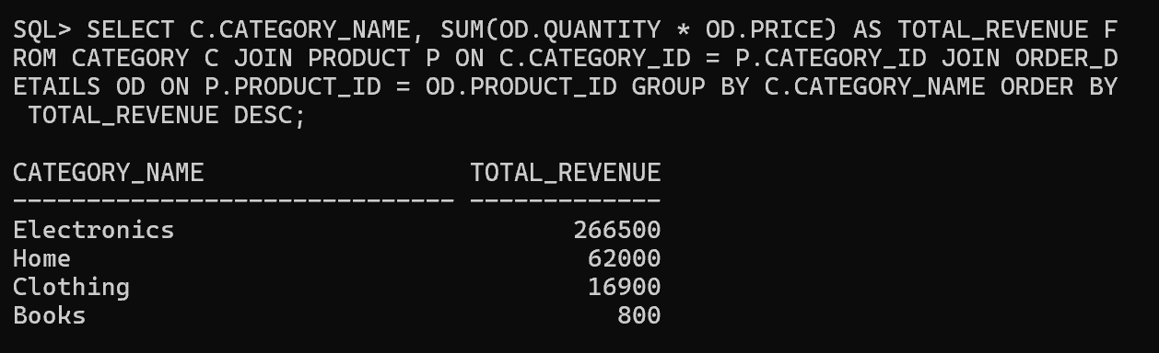
- Top-selling products
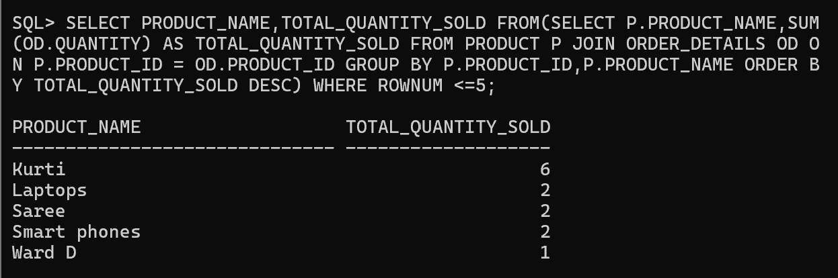
Report 4: Business Decision Report
Identify:
- High-performing products
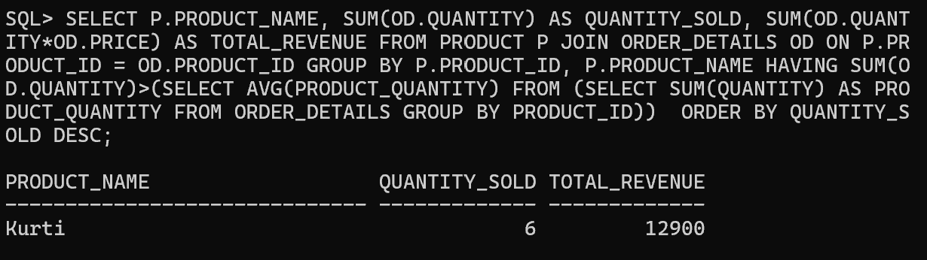
- Low-performing products
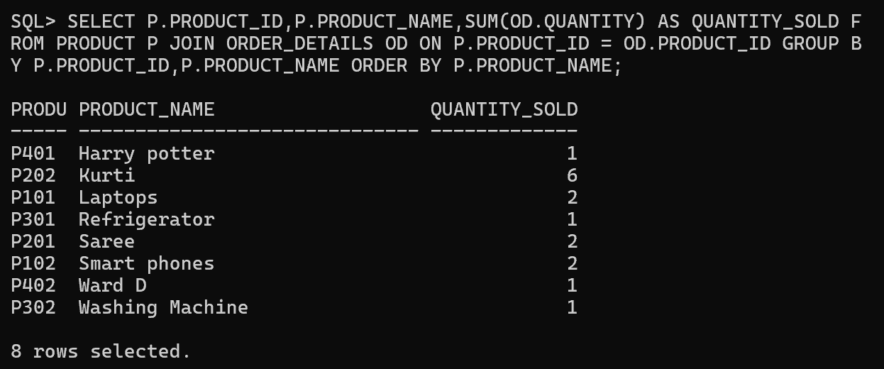
- High-value customers
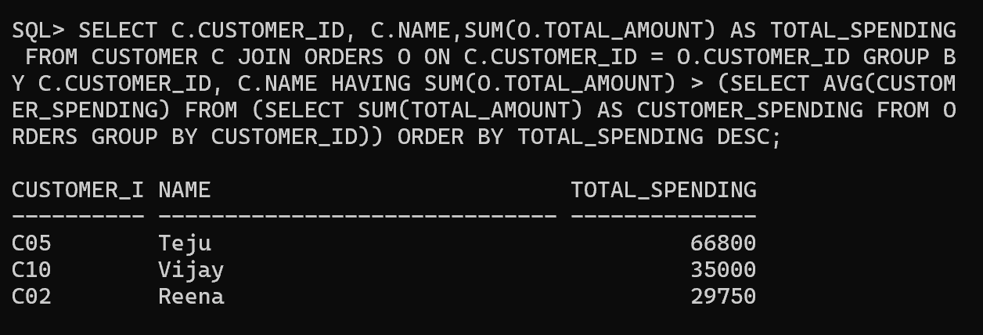
- Revenue trends


